DS103 Kanban Board HandsOn

To the best of my ability, here is my Kanban board for ABC Inc. Registration.

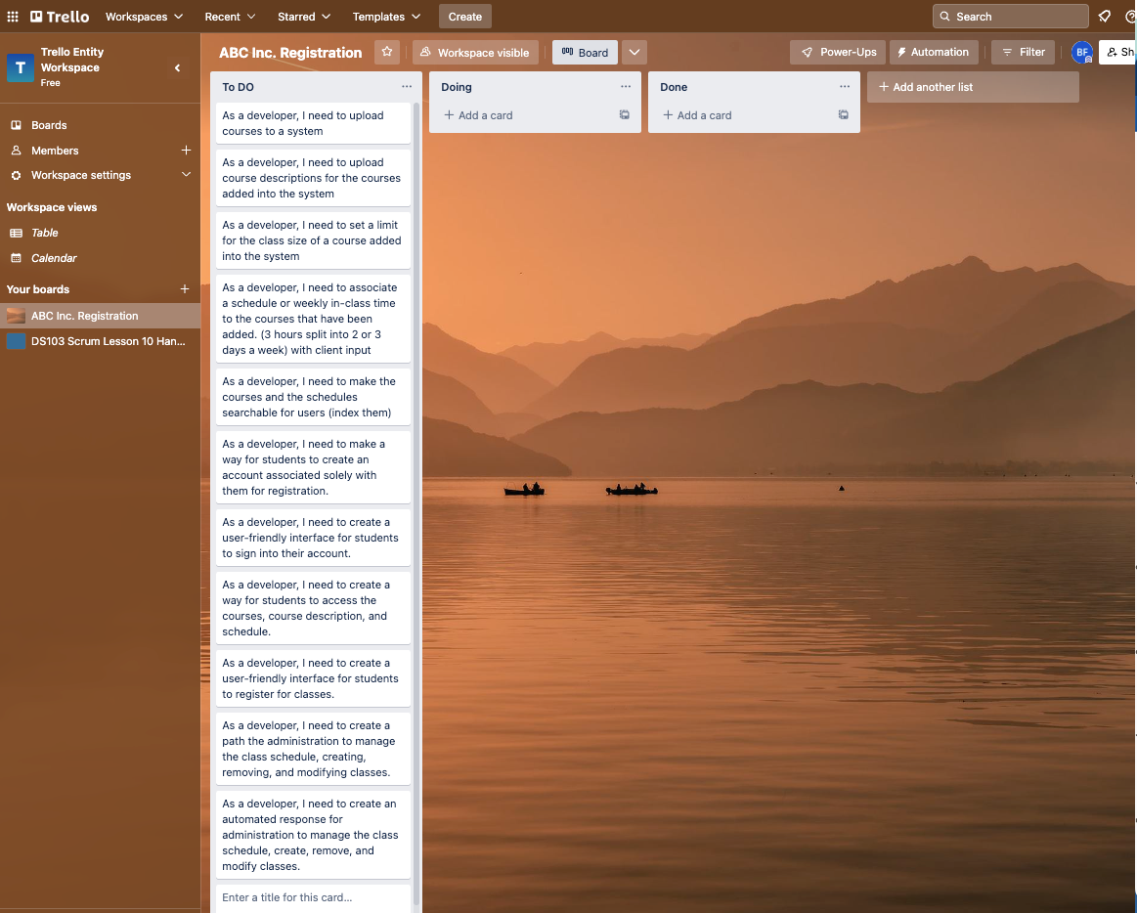

<https://trello.com/invite/b/Hr4oJEpi/ATTI9a6c132a6d6d470bc2f63a69303f66eaD1330480/abc-inc-registration>